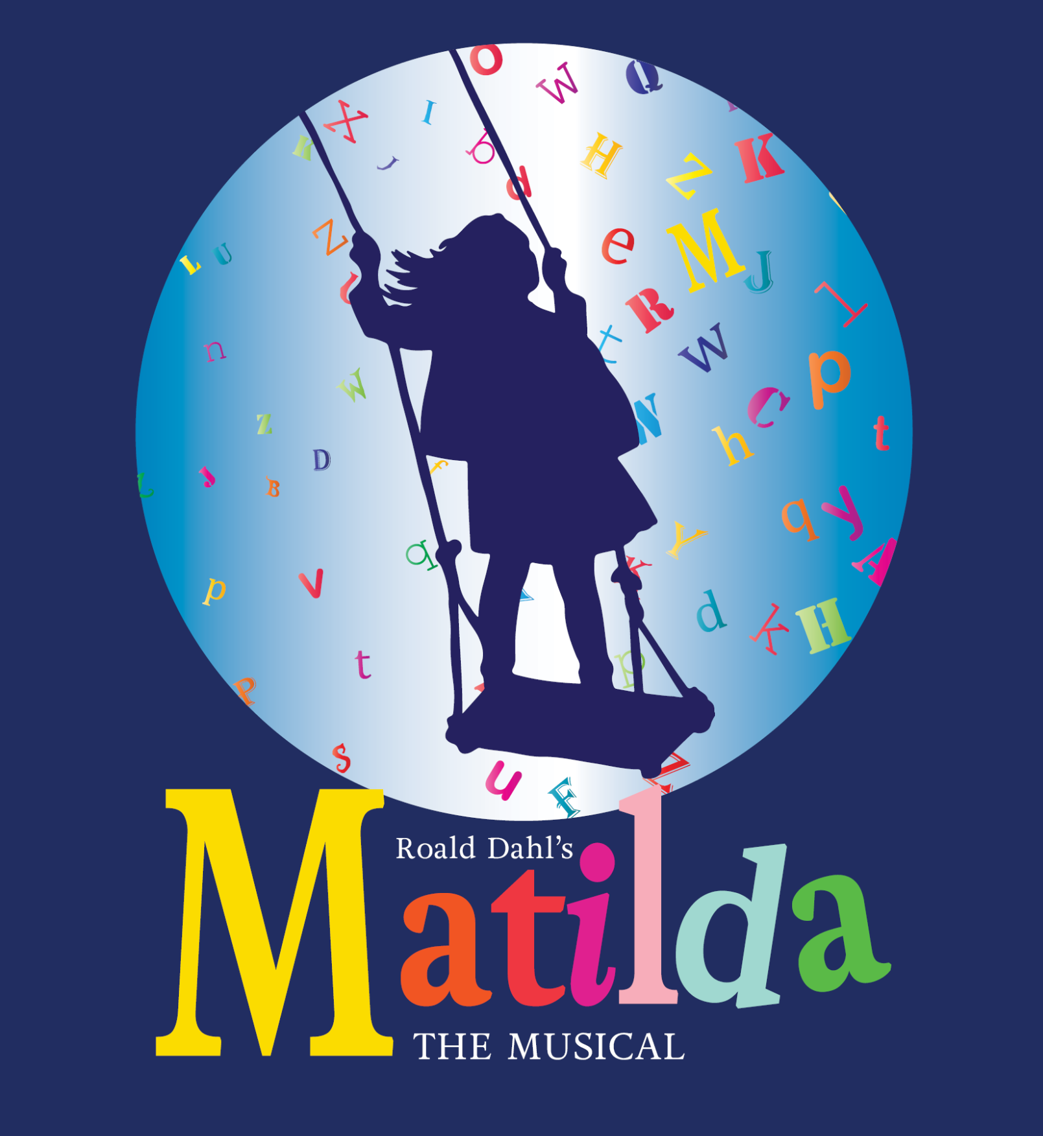
Direction and Musical Direction by Kate Maras Haulter

Performance Dates
Thu. Jul 9th 2026, 7:30 pm
Fri. Jul 10th 2026, 7:30 pm
Sat. Jul 11th 2026, 7:30 pm
Sun. Jul 12th 2026, 2:00 pm
Fri. Jul 17th 2026, 7:30 pm
Sat. Jul 18th 2026, 2:00 pm
Sat. Jul 18th 2026, 7:30 pm
Sun. Jul 19th 2026, 2:00 pm

Please read all that is listed below before signing-up for an audition!
Full Tech Rehearsals: MANDATORY ATTENDANCE:
Wednesday, July 1st 5:30-finish
Thursday, July 2nd, 5:30-finish
NO REHEARSALS FRIDAY, SATURDAY, SUNDAY
Monday, July 6th, 6:00-finish
Tuesday, July 7th, 6:00-finish
Wednesday, July 8th, 6:00-finish
Music rehearsals will begin in April 2026.

Audition Information:
All auditions will take place at Hayswood Theatre
Auditions will take place April 20-21, 2026, and callbacks will be on April 22nd.
All auditions will take place during the times listed above. Video auditions will not be considered for this production. No auditions will take place on dates before or after those posted above.
Auditions are separated by appropriate age/similar ages for characters. Please adhere to the age distinctions when signing-up.

Bringing a headshot and current theatre resume to your audition is highly encouraged, but not required.

Casting:
All roles are open for casting, no roles have been precast.
Previous dance experience is not required for this production
This is a great show for beginners!

A listing of all roles is at the end of this document.

Audition requirements:

Children, who are currently in grades 3-7: Should be prepared to sing the excerpt of “When I Grow Up”, as well as read one of the monologues in the Google Folder.

Practice track with singing: https://www.youtube.com/watch?v=xrOxvSsg6IM

Instrumental only track (this is what you will need to sing with at auditions): https://www.youtube.com/watch?v=yMFvrqgJ5oo

Teens (grades 8 through high school) and Adults: Please prepare 30-60 seconds of an upbeat musical theatre song. Please be prepared to play accompaniment (YouTube videos are fine, as long as there are no singers in them). You will be asked to do cold readings from the Script.

Because the rehearsal process will take place primarily in the summer months, it is extremely important that lists of conflicts and family vacations are submitted at auditions. Please bring a complete list of conflicts to auditions.

Click here for the audition sign-up: https://tinyurl.com/3ua2z2h3

Matilda Character List

Character Descriptions

All ages listed is a place to start from and can be flexible depending on audition turnout. We will be looking at children of all ages, including high schoolers.

Matilda Wormwood - Female, Age: 6-10. An imaginative girl who is clever and wise far beyond her years. She has a thirst for learning that cannot be quenched. Likable and charismatic, not annoying or pretentious. Honest and unassuming, but with a prankster streak and a strong sense of justice. Must be a very strong singer and actress, equally. Strong dancing skills preferred but not required.
Vocal range top: D5 Vocal range bottom: A3

Miss Agatha Trunchbull - Male or Female, Age: 35-55. The tyrannical headmistress at Matilda's school who despises children. Male in female clothing/makeup/hair, or female. A cruel and sadistic person, but not a brute or brash - rather, sly and conniving, cunning and slinky. Above all, must be a strong actor with a good sense of physicality and characterization. Strong singer and dancer preferred.
Vocal range top: G4 Vocal range bottom: A2

Miss Jennifer Honey - Female, Age: 25-40. Matilda's kindhearted teacher. She is tired of living in fear under Miss Trunchbull. Sweet, honest, caring, and intelligent, Miss Honey is timid but willing to become brave and stand up to bullies in order to protect her students. Must be a lovely, strong singer and a strong enough actor to make the role truly compelling.
Vocal range top: D5 Vocal range bottom: F3

Mr. Wormwood - Male, Age: 35-45. Matilda's uncaring father. A slimy, greedy used-car salesman, unintentionally hilarious. Must be a VERY strong actor and comedian; improv and dance skills preferred. Must also be a relatively strong singer.
Vocal range top: A4 Vocal range bottom: D3

Mrs. Wormwood - Female, Age: 35-45. Matilda's self-absorbed, negligent mother and an amateur ballroom dancer. Must be a VERY strong comedic/character actress, dancer, and singer able to carry off a sizable comedic role.
Vocal range top: F5 Vocal range bottom: A3
Bruce - Male, 7-14. Matilda's classmate. He is subject to punishment by Miss Trunchbull. Bruce is a genuine, kind boy with a fondness for sweets; his spirit is broken by the Trunchbull but he bounces back stronger than ever. Must be a very strong actor and singer with monologues, scenes, and solos. Strong dance skills preferred.
Vocal range top: E5 Vocal range bottom: C4
Lavender - Female, Ages: 7-10. Matilda's classmate and best friend. Lavender is squeaky and super-adorable, and what she lacks in intelligence she makes up for in enthusiasm and friendliness. Must be a very strong actor and singer with monologues, featured scenes, and solos throughout. Strong dance skills preferred.
Tommy, Eric, and Nigel - Males, Ages: 7-14. Matilda's boy classmates. Each has important lines and solos, and some have featured dance moments as well. Strong singers, actors, and dancers required.
Amanda, Alice, and Hortensia - Females, Ages: 7-14. Matilda's girl classmates. Each has important lines and solos, and some have featured dance moments as well. Strong singers, actors, and dancers required.
Michael Wormwood - Male, Age: 10-15. Matilda's slightly older brother. He is a deadpan comedic character, with various lines and “bits” throughout the show. Must be a strong comedic actor. Will also be a “Big Kid.”
Vocal range top: E5 Vocal range bottom: C4
Ensemble – male and female , play the Mums and Dads in the opening number “Miracle”. These performers will also double as various adult speaking and singing roles throughout the show. Strong singers, actors and dancers required.
- Doctor - The doctor who delivers Matilda. Vocal range top: A4. Vocal range bottom: C3.
- Mrs. Phelps - A kindly librarian and Matilda’s friend. No solos or dance features; many lines.
- The Escapologist - A character in Matilda’s story. Vocal range top: E4. Vocal range bottom: C3.
- The Acrobat - A character in Matilda’s story. Vocal range top: A4. Vocal range bottom: D4
- Rudolpho - Mrs. Wormwood’s dancing partner. Vocal range top: A4. Vocal range bottom: D#3.
- Competitive Dancers - Mrs. Wormwood and Rudolpho’s dancing competition.
- Judge - The judge at Mrs. Wormwood and Rudolpho’s dancing tournament.
- Cook - The cook at Miss Trunchbull’s school.
- Mechanic - A mechanic who works for Mr. Wormwood at the used car lot.
- Sergei - A Russian mob boss who Mr. Wormwood rips off.
- Henchmen/Henchwomen - Sergei’s Russian associates who threaten the Wormwoods.

